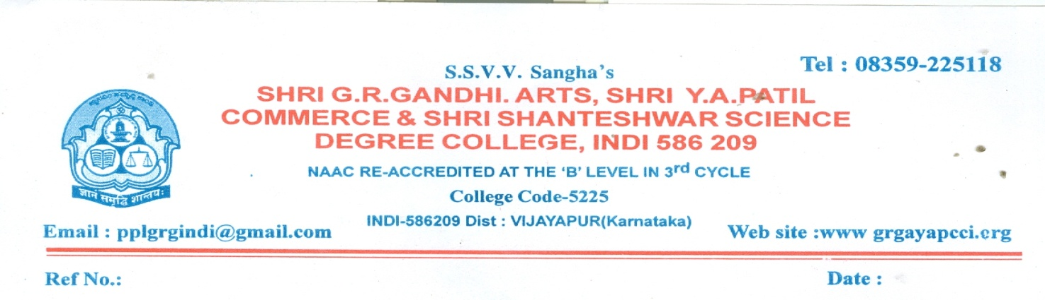
Calendar of the Events for the Academic year
2017-18
Sl .no | I Term
1 | 19-06-2017 | Reopening Day
2 | June 3rd Week | Commencement of classes
3 | June 3rd Week | Induction programme for 1st year students
4 | August 2nd week | Inauguration of cultural activities
5 | August last week | 1st internal test
6 | September 3rd week | Alumni and parents meet
7 | October 1st week | 2nd internal test
8 | October 2nd week | Conducting certificate course
9 | November 3rd week | Commencement of main exam
Sl no | II Term
1 | 16th December | Reopening day
2 | December 3rd week | Commencement of classes
3 | December last week | AIDS awareness programme
4 | 25th January | National voters day
6 | February 2nd week | 1st internal test
8 | 8th March | World women’s day
10 | March 3rd week | NSS Camp
11 | March 4th week | II internal test
14 | April 3rd week | Feedback collections from students
15 | April 3rd week | Annual day
16 | May 3rd week | Commencement of main exam
Calendar of the Events for the Academic year
2018-19
Months | Date | Events
June | 21.06.2018  25.06.2018 | - Reopening of the college for the academic year 2018-19
 | 26.06.2018 | - Tentative time table  - Commencement of theory and practical
 | 4th week | - Regular time table
July | 1st week | - Preparation of teaching plan
 | 2nd week | - Orientation programme for first semester UG Students
 | 4th week | - 31st july last date for admission for I Semester  - Freshers day by UG Students
Aug | 1st week | - Alumni association meeting
 | 2nd week | - Independence day 15th August
 | 3rd week | - First internal test examinations for odd semester
September
 | 2nd week | - Hindi day
 | 3rd week | - Second internal test examination for odd semester
 | 4th week | - NSS Day 24th September
October | 1st week | - Mahatma Gandhiji and Lal bahudar Shastri Jayanti 2nd Oct
 | 3rd week | - Internal practical Examination
 | 22.10.2018 | - Last working day of odd semester
 | From  25.10.2018 to  08.12.2018 | - Practical examination conducted by RCU,Belgaum  - Odd semester vacation / Exam/Valuations /Result – By RCU Belagavi
December | 01.12.2018 | Aids awareness camp
 | 17.12.2018 | Reopening of the college for 2nd, 4th and 6th semester
January | 1st week | - NSS Special Camp
 | 2nd week | National youth Day and Vivekanand Jayanti on 10th
 | 26.01.2019 | Republic day
February
 | 2nd week | - First internal test examination for even semester
March | 1st week | - International womens day
 | 2nd week | - Second internal test for even semester
 | 3rd week | Internal practical examinations
 | 4th week | Parents and alumni meeting
April
 | 2nd week | Practical examination conducted by RCU Belgaum
 | 3rd week | Last working day 17th April 2019

Calendar of the Events for the Academic year
2019-20
Months | Date | Events
June | 17.06.2019 | - Reopening of the college for the academic year 2018-19  - Address by the principal
 | 2nd week | - Tentative time table  - Commencement of theory and practical
 | 3rd week | - NSS enrolment
 | 4th week | - Display of teaching plan
July | 1st week | - Orientation programme for first semester UG Students  - HOD Meeting  - Telecast of union Budget
 | 2nd week | - World population day
 | 4th week | - Inauguration of gymkhana and cultural activities
Aug
 | 2nd week | - Independence day 15th August
 | 3rd week | - First internal test examinations for odd semester
September
 | 2nd week | - Hindi day
 | 3rd week | - Second internal test examination for odd semester
 | 4th week | - NSS Day 24th September  - Alumni meet  - GST W0orkshop  - Janapada Vichara Snakirna
October | 1st week | - HOD Meeting
 | 19.10.2019 to 03.12.2019 | - Practical examination conducted by RCUB  - Odd semester vacation / Exam/Valuations /Result – By RCU Belagavi
November | 1st week | Central valuation conducted by RCUB
 | 3rd week | Constitution day
December | 04.12.2019 | Reopening of the college for 2nd, 4th and 6th semester
 | 2nd week | - HOD Meeting / Staff meeting  - Annual sports meet for the year 2019-20
 | 4th week | - NSS Special Camp
January | 1st week | - Certificate course  - Projects
 | 4th week | - Republic day celebration  - Ladies association function  - National voters day  - Study tours
February | 1st week | - First internal test examination for even semester
 | 3rd week | - Study tours for various departments
 | 4th week | - Science day
March | 1st week | - Second internal test for even semester
 | 2nd week | - Practical internal test conducted by RCUB
 | 3rd week | Valedictory functions of Gymkhana and associations farewell to final year students
 | 4th week | Parents and alumni meeting
April | 18.04.2020 | Last working day and principal meeting with staff

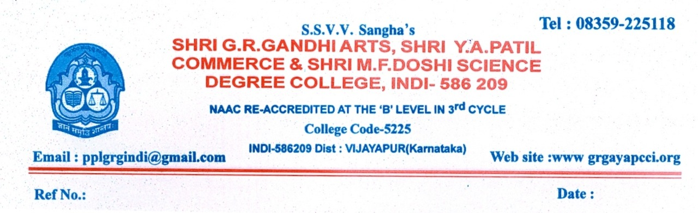
Calendar of the Events for the Academic year
2020-21
Months | Date | Events
Aug | 01.08.2020  (Online) | - Reopening of the college for the academic year 2020-21  - Address by the principal
 | 2nd week | - Tentative time table  - Commencement of theory of 3rd and 5th sem online
 | 3rd week | - Display of Teaching plan
 | 4th week | - Display of Regular time table for 3rd and 5th sem online
September | 1st week | - HOD Meeting
October | 1st week | - Gandhi Jayanti
November | 1st week | - Kannada Ranjoytsva
December | 1st week | - Commencement of theory and practical classes for 3rd and 5th sem
January | 1st week | Commencement of theory and practical classes for 1st sem
 | 4th week | - Republic day celebration  - National voters day  - First internal test for 3rd and 5th sem
February | 1st week | - Telecast of union budget  - Inauguaration of gymkhana and association activities  - Study tour
 | 4th week | - Science day celebration  - Last working day for the theory and practical classes of 5th sem
March | 1st week | - Commencement of RCU Practical examinations for 5th sem
 | 2nd week | - Last day for theory and practical of 1st and 3rd sem
April | 2nd week | - RCU Practical Examinations for 1st and 3rd sem
May | 1st week | - Reopening of college for 2nd , 4th and 6th sem  - Disply of Regular time table
 | 2nd week | - Teaching plan
 | 3rd week | - NSS Special Camp
June | 1st week | Projects
 | 2nd week | Certificate course
 | 4th week | First internal test for even semester
July
 | 2nd week | Second internal test for even semester
 | 3rd week | Internal practical test
August | 2nd week | - Independence day  - Validectory function of Gymkhan and association activities  - Farewell to final year students
 | 3rd week | - Last working day of even sem  - Principal meeting with staff
